DBS Individual Project

Assessment Objectives:
- Understanding software development process;
- Understanding Visual Studio environment and C# development environment;
- Understanding of the good user interface and basic programming features;
- Understanding of flow chart
- Creation of professional wireframe and project specification document
- Able to apply logical thinking to create correct flow charts based on wireframe

Software required: MS Visual Studio, MS Word

Duration: 6 weeks

Weightage: This project constitutes 20% of your overall DBS grade.

For submission of your work,
- Save the document using the naming convention Class-StudentName.docx, for example, TB01- VinceKoh.docx.

Plagiarism Policy
If plagiarism is found, the following penalties apply:
• If two or more students are involved in plagiarism, the penalty will apply to all students involved, regardless of which student originated and lent the work to be copied, and who plagiarized it.
• In the case of group projects where a portion of the work has been plagiarized, the student responsible for the plagiarized portion will face the penalty. Where it is not clear who is responsible for the plagiarism, all group members will be held responsible and all will face the penalty.
• First Instance of Plagiarism – if plagiarism has occurred, the student will receive zero mark for the assignment.
• Second Instance of Plagiarism – student will be interviewed by the School Disciplinary Committee and if found to have plagiarized the second time, the student will fail that module.
• Third Instance of Plagiarism – student will be referred to the NP Student Disciplinary Committee. This may result in expulsion or dismissal from the Polytechnic

Late Submission of Coursework
The following penalty will apply for late submissions without valid reasons:
• For each day past the deadline, 10% of the total possible mark will be deducted, up to a maximum of 7 calendar days. After which, zero mark will be given.
For example, a student submits an assignment 2 days after the deadline. He/She has scored 65 marks out of a maximum of 100 marks for the assignment. 20 marks (10 marks * 2 days) will be deducted from the mark he/she has attained. The final mark that the student has attained will be 45.

Sample Project Scenario Description

You are hired by a new start-up company to manage their drone products. Currently, potential customers phone each day to enquire detail and prices of different types of drones. They are also interested to know the different accessory parts and various maintenance packages. As the business grows, customers have to wait for a long time before they can get answers from the sales supports, who are overwhelmed by the customer enquiries.

The company would like you to develop an easy-to-use program one window* application to ease the situation. The program should have the following key features:

- A featured product section to display the top-3 selling drones, and allow customers to buy by clicking any of the 3 drones.

- A product list section to display all the 6 drones. At any one time, customers can click on one of the products to view product detail, image and price.

- An add-on section to display the parts they can upgrade. Currently, the options available are better quality of lithium battery, cameras and antennas. Customers can choose to upgrade all of them.

- A section to display maintenance and repair packages: Basic, Advance and Premium. Your group need work out the details of the packages.

- Customers should be able to specify the quantity of drones they are buying. **

- A discount price will be given to customers if total purchase price exceed certain amount. Your group need to work out the discount prices and amounts.

- A promotion code section for customer to enter promotion code to get extra discount during the promotion period. Your group need to work out various promotion codes.

- When the BUY button is clicked, a purchased summary will be calculated and displayed.

*One Window: Means everything is displayed in one single window.
**To make it simple, in this project, you can assume:
  - At any one time, customers can only buy multiple quantity of one type of drone
  - The quantity for the upgraded parts as well as the maintenance package is equal to the quantity of the drones purchased.

Project Schedule

Step 1: Create your own project scenario and data (To be completed by week 3 – 15 Marks)

>>>>>> [Paste your project scenario here] <<<<<<

Based on your project scenario, determine the detail, image and price of the products you are going to sell.

6 products or services

S/No | Product Name | Product Image | Unit Price | Detail Specification
1
2
3
4
5
6

Top 3 products or services

S/No | Product Name | Product Image | Unit Price | Detail Specification
1
2
3

3 Add-ons (Replace Lithium Battery, Cameras, Antennas with your own add-ons)

S/No | Product Name | Product Image | Unit Price | Detail Specification
1 | Lithium Battery
2 | Cameras
3 | Antennas

Maintenance Packages (or equivalent)

S/No | Package Name | Unit Price | Detail Specification
1 | Basic
2 | Advance
3 | Premium
Discount Schemes (minimal 3 schemes)

S/No | Based on Minimum Total Amount | Discount Given
1 | >= $1000 | 10%
2 | >= $2000 | 20%
3

Promotion Codes (minimal 3 codes)

S/No | Promotion Code | Discount Given
1 | “blackFriday” | 5%
2
3

Step 2: Wireframe (To be completed by week 6 – 35 Marks)
Use Visual Studio to create a good wireframe of the user interface and paste it below. You need to provide the name and properties for the necessary controls. You can refer to the workshop document on how a good wireframe is.

Step 3: Flow Charts (To be completed by week 8 – 50 Marks)

For the following scenarios, create flow charts to illustrate what will happen and paste it below the heading.
You can watch a YouTube video on how to create flow charts.
Here are two sample flowcharts for your references.
Sources: https://www.edrawsoft.com/en/algorithm-flowchart-examples.html

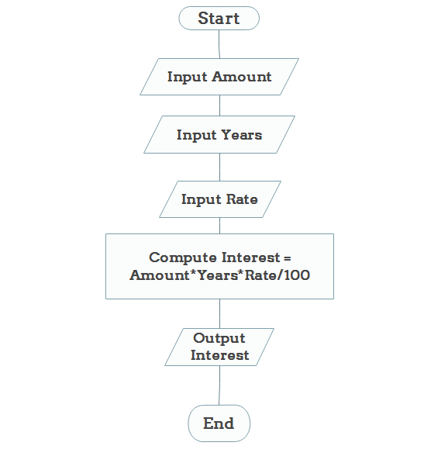 | 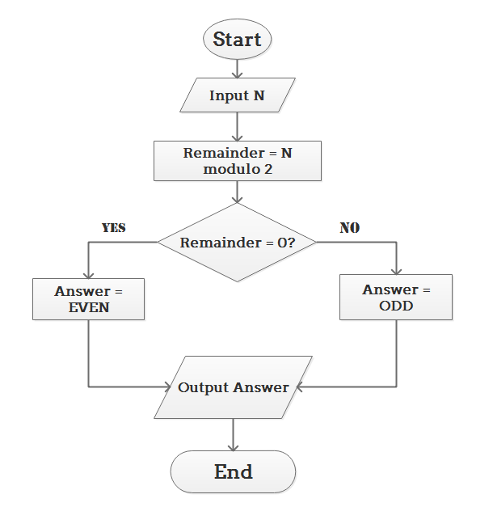

Flow Chart for selection of a product in Featured Product section
Create a flow chart for what the code needs to do when users click a product.

Flow Chart for selection of a product in Product List section
Create a flow chart for what the code needs to do when users click a product.

Flow Chart for selecting add-ons in Add-On section
Create a flow chart for what the code needs to do when users select an Add-on.

Flow Chart for Maintenance Packages
Create a flow chart for what the code needs to do when users click a package.

Flow Chart for clicking on Buy button
Create a flow chart for what the code needs to do when users click the buy button.

Step 4: Submission in MeL (Submit by Week 8)

- Consolidate your project case, data, wireframes and flowcharts in this word document
- Format your document professionally
- Save the document using naming convention Class-StudentName.docx, for example, TB01- VinceKoh.docx
- Submit the saved document in MeL under DBS module project folder.

Project 1 - Marking Criteria

Category | Marks | Submit By
Project Scenario and Data  - Create business value  - Serve a new market segment  - Completeness of data collection  - Realistic data  - Professional Formatting of document and data | /15 | Week 3
Project Wireframe  - Professional wireframe  - Use of proper Controls  - Good naming convention for controls | /35 | Week 6
Project Flow Charts  - Proper drawing and format of all flow charts  - Completeness of all flow charts  - Correctness of all flow charts | /50 | Week 8

Project Business Case

Guiding questions:
- What is the business selling / dealing with?
- Who will be the targeted users of the Windows Form application that you will be designing?
- At which part of a business process will the Windows Form application be used?
- Where will the Windows Form application be deployed?
- What are the features on the Windows Form application?

Wireframe - What is the look and feel of the Windows Form application?

Example:
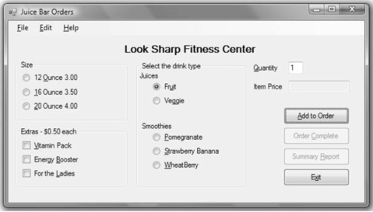

Flowcharts - How would the users navigate / use the Windows Form application?

Example:

